Page 1

CACHE CONTROLLER PROJECT

Aaishwary Vadodariya (aaishv@gmail.com)

Electrical and Electronic Engineering

College of Engineering & Computer Science

California State University Sacramento

Page 2

TABLE OF CONTENTS

1. | Introduction | 3
2. | Main memory 4 M bytes (1M Long Word –LW) | 4
3. | Total Cache size 8 K bytes (2 K LW) | 7
4. | 4 way set associative | 8
5. | Each Set Cache 2 K bytes (512 LW) | 12
6. | Block size 64 LW | 13
7. | 4 Lines per block | 14
8. | Line size 16 LW | 15
9. | Cache replacement policy - LRU | 16
10. | 8 and 16 bit requests are non-cacheable | 17
11. | I/O transfers are non-cacheable | 18
12. | Read cache miss Long word access | 19
13. | Cache write | 20
14. | Bus snooping circuits – MESI protocol | 25
15. | Memory pages 100 to 200 are non-cacheable | 28
16. | Flush circuitry to invalidate the entire Cache | 29
17. | Conclusion | 31
18. | References | 32

Page 3

INTRODUCTION

A memory is just like a human brain. It is used to store data and instructions. Computer memory is the storage space in computer where data is to be processed and instructions required for processing are stored. In memory, information is stored as patterns of bits. A bit is a single on/off value. Only two values are possible. The two values may go by different names, such as true/false, or 1/0. One bit of information is so little that usually computer memory is organized into groups of eight bits. Each eight-bit group is called a byte. One byte is about enough memory to hold a single character. So one K of memory is 1024 bytes (which happens to be 1024*8 == 8,192 bits).

MAIN MEMORY

Main memory is as vital as the processor chip to a computer system. It is constructed from integrated circuits and needs to have electrical power in order to maintain its information. When power is lost, the information is lost too. It can be directly accessed by the CPU. The CPU will normally transfer data to and from the main memory in groups of two, four or eight bytes, even if the operation it is undertaking only requires a single byte.
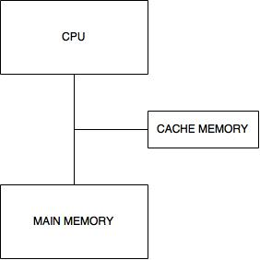
Page 4

1. MAIN MEMORY 4 M BYTES (1M LONG WORD –LW)

Let's assume that we have 1M of RAM. RAM is also called physical memory. We can subdivide the RAM into 4K pages. Thus 1M / 4K = 256 pages. Thus, our RAM has 256 physical pages, each holding 4K.

Here our Main memory is 4M bytes.

Thus let’s assume each page is 2KB size

Therefore, 4M/2K = 2048 pages

Thus main memory is having 2048 pages each having 2K Bytes.
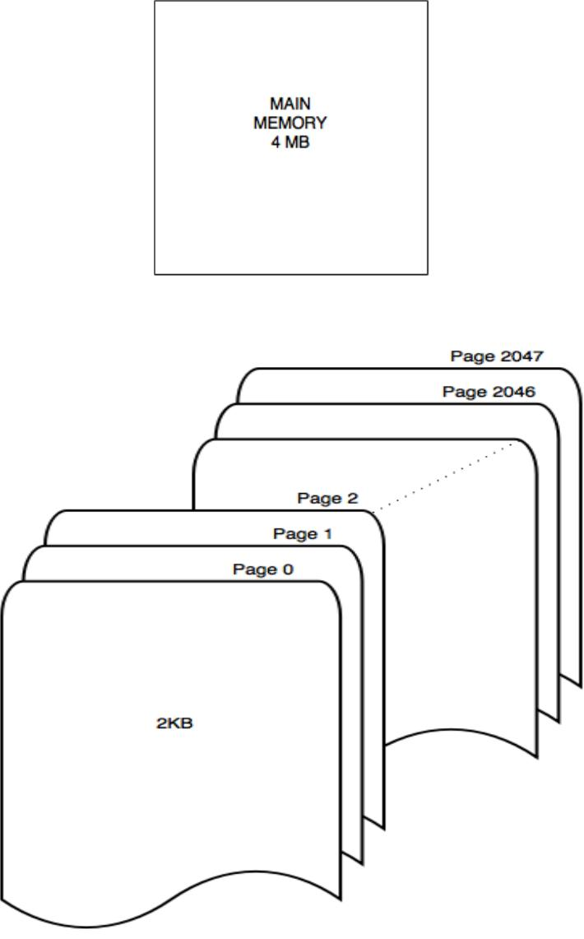
Page 5

CACHE MEMORY

Processors are generally able to perform operations on operands faster than the access time of large capacity main memory. Though semiconductor memory which can operate at speeds comparable with the operation of the processor exists, it is not economical to provide all the main memory with very high speed semiconductor memory. The problem can be alleviated by introducing a small block of high speed memory called a cache between the main memory and the processor.

The basic purpose of cache memory is to store program instructions that are frequently re-referenced by software during operation. Fast access to these instructions increases the overall speed of the software program.

As the microprocessor processes data, it looks first in the cache memory; if it finds the instructions there (from a previous reading of data), it does not have to do a more time-consuming reading of data from larger memory or other data storage devices.
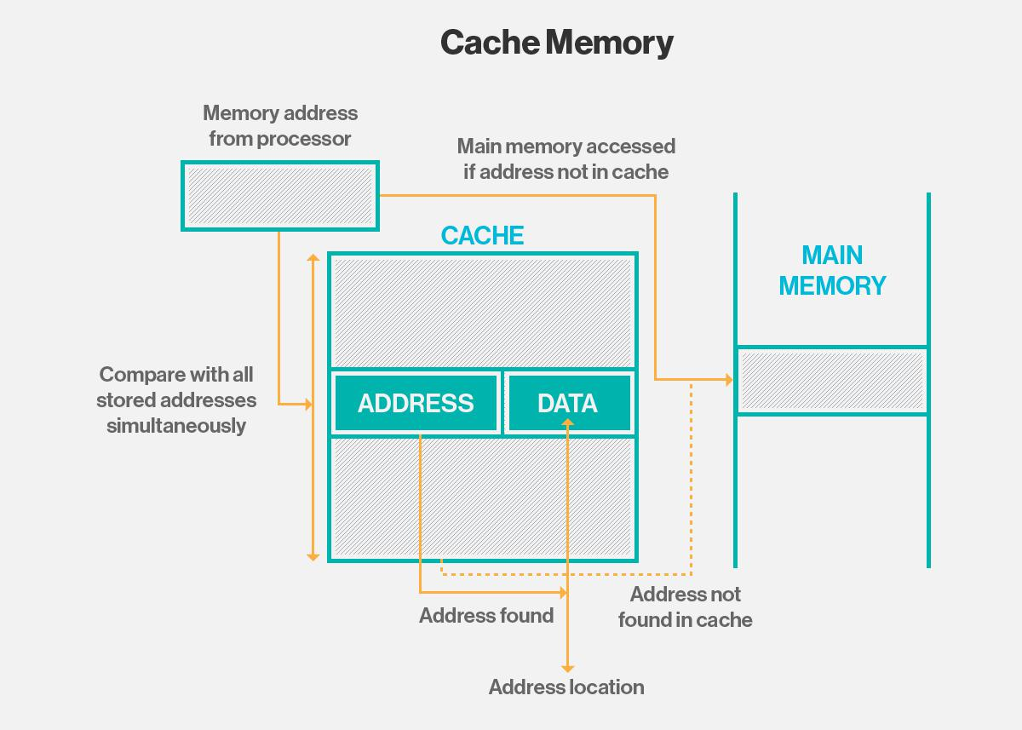
Page 6

CACHE MEMORY LEVELS

Cache memory is fast and expensive. Traditionally, it is categorized as "levels" that describe its closeness and accessibility to the microprocessor:

- Level 1 (L1) cache is extremely fast but relatively small, and is usually embedded in the processor chip (CPU).
- Level 2 (L2) cache is often more capacious than L1; it may be located on the CPU or on a separate chip or coprocessor with a high-speed alternative system bus interconnecting the cache to the CPU, so as not to be slowed by traffic on the main system bus.

- Level 3 (L3) cache is typically specialized memory that works to improve the performance of L1 and L2. It can be significantly slower than L1 or L2, but is usually double the speed of RAM. In the case of multicore processors, each core may have its own dedicated L1 and L2 cache, but share a common L3 cache. When an instruction is referenced in the L3 cache, it is typically elevated to a higher tier cache.
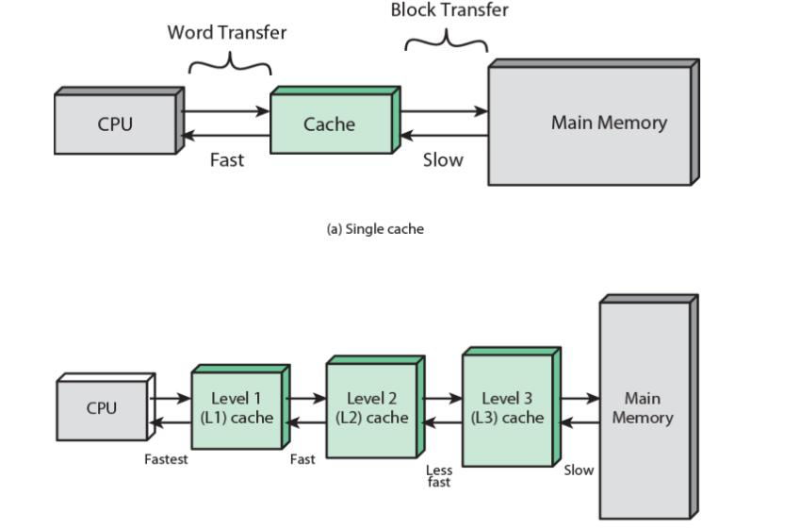
Page 7

2. TOTAL CACHE SIZE 8 K BYTES (2 K LW)

Cache is also a type of RAM, but it is Static RAM – SRAM. SRAM are faster and costlier then DRAM because it has flip-flops (6 transistors) to store data unlike DRAM which uses 1 transistor and capacitor to store data in form of charge. Moreover, they need not be refreshed periodically (because of bi-stable latching circuitry) unlike DRAM making it faster. The basic cache design parameters are cache size, block size, and associativity.

In this project we use 8KB cache memory i.e. 4 banks each having size of 2K LW (total of 8 KB).
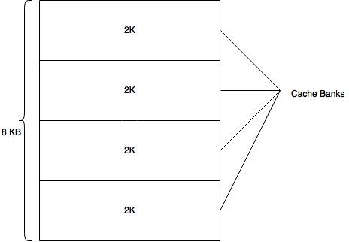
Page 8

3. 4 WAY SET ASSOCIATIVE

A cache is organized as a two-dimensional array of blocks. The rows are called sets, and the columns are called ways. At the one extreme there is only one set. This is a fully-associative cache. In this case the number of ways equals the number of blocks.

Caching configurations continue to evolve, but memory cache traditionally works under three different configurations:

- Direct mapping, in which each block is mapped to exactly one cache location. Conceptually, this is like rows in a table with three columns: the data block or cache line that contains the actual data fetched and stored, a tag that contains all or part of the address of the fetched data, and a flag bit that connotes the presence of a valid bit of data in the row entry.

- Fully associative mapping is similar to direct mapping in structure, but allows a block to be

mapped to any cache location rather than to a pre-specified cache location (as is the case with direct mapping).

Set associative mapping can be viewed as a compromise between direct mapping and fully associative mapping in which each block is mapped to a subset of cache locations. It is sometimes called N-way set associative mapping, which provides for a location in main memory to be cached to any of "N" locations in the L1 cache.

Given an address from the CPU we need to index the cache. By this we mean, selecting the set in which the address may be cached. The common indexing scheme partitions the incoming address into three fields. Starting from the MSB these are the TAG, SET and OFFSET:
Page 9
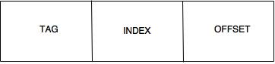

index => which set

tag => which data/instruction in block

offset => which word in block

In this project, 4 way set associative organization is used in cache memory. This means that the 8kb cache is divided into 4 ways. Sets are also referred to as cache banks. Since the memory will have a choice to store data in 4 ways/cache banks, it is called as four way set associativity. Each cache bank will enclose 2k bytes (512 LW) of memory. Each bank will have its own directory. For every request from the CPU that has to be assessed, the request has to be run through every directory to compare and find the required cached data.
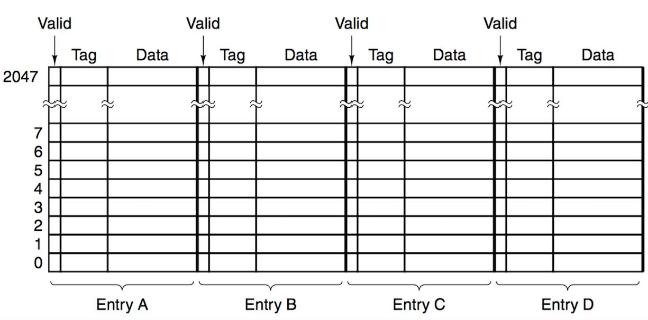

Fig: 4 way Set Associative
Page 10

In this project, 2KB cache, with 64LW block size, 4-way Set-Associative, write-through with LRU replacement is used. Assume a 32-bit byte-addressable address space. In this case, there are 2^32 different byte addresses.

So we have Capacity = 8KB = 2^11 bytes, Block Size = 64LW = 2^8 bytes, associativity = 4 = 2^2.

The capacity refers to the total number of data bytes that the cache can store. It does not include the overhead bits required by the tags, valid bits and LRU bits.

From the size of the blocks we can immediately derive the width of the offset field. It holds that

Offset width = log₂(Block Size)

So, in this case Offset width = 8 bits.

To find the width of the SET field we need to determine the number of rows. To do that we need to determine the number of blocks. We are given that this is a 4-way set-associative cache; hence each set has four blocks.

It holds:

#Blocks = Capacity / Block Size = 2^11 / 2^8 = 2^3. There are 8 blocks.

#Sets = #Blocks / #ways = 2^3 / 2^2 = 2. There are 2^2 sets, hence the SET field is 2 bit wide.

TAG field is 32 – 2 – 8 = 22 bits wide.
Page 11

So the indexing is done as follows:
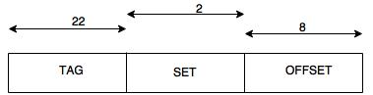

To access the cache, we first use the 2 SET bit to select one of the 4 sets. Then we compare the TAG field with the TAG fields of the four blocks that belong to the set. If a match is found, we finally use the OFFSET field to select the appropriate byte out of the 256 stored in the block.
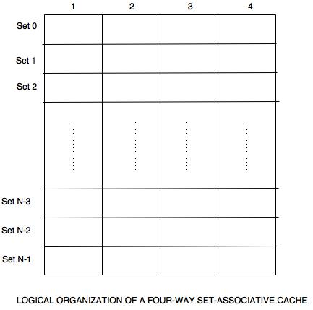
Page 12

4. EACH SET CACHE 2 K BYTES (512 LW)

It is mentioned that the total cache is 8KB and each set in cache is 2KB (512 LW).

Therefore, there are a total of 4 sets of cache, each comprising 2KB.
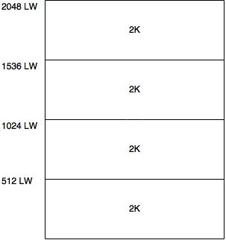
Page 13

5. BLOCK SIZE 64 LW

Each cache bank/set can be organized into blocks. This makes it easier for the controller to search through the respective blocks and find the requested data. This is possible due to the address locations assigned to the sets and also further within the blocks.
In this project, each cache bank/set of 2KB (512 LW) is further divided into several blocks. Each block size is 64 LW.

Therefore, total number of blocks per set is 512 LW/64 LW = 8 blocks
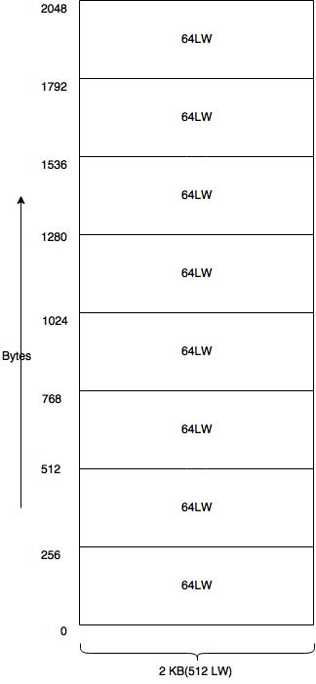
Page 14

6. 4 LINES PER BLOCK

Each block is designed to have 4 lines.

In this project, each block size is 64 LW.
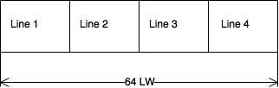
Page 15

7. LINE SIZE 16 LW

Each line has to accommodate 16 LW.

Therefore, each line contains = 16*4 = 64 bytes

So, total of 4 lines = 64*4 = 256 bytes thus, satisfying the design condition of a block in this project.
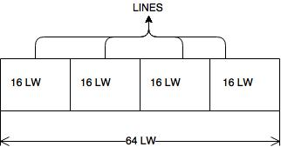
Page 16

8. CACHE REPLACEMENT POLICY - LRU

In general, a cache is too small to hold all the data we might possibly need, so at some point data has to be remove from the cache in order to make room for new data. The goal is to retain those items that are more likely to be retrieved again soon. This requires a sensible algorithm for selecting what to remove from the cache. One simple but effective algorithm is the Least Recently Used, or LRU, algorithm. When performing LRU caching, cache always throw out the data that was least recently used.

Let’s consider an example to understand the working of LRU in a 4 way set associative, consider we have,

Now if 500 is loaded, then it will take place of 100 as tag is highest.
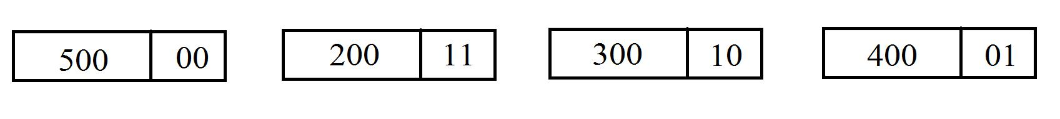

Let’s say again 400 has to be accessed, then,
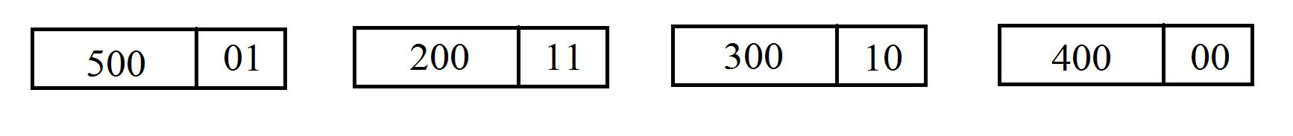

Let’s say 200 has to accessed again, then,
Page 17

- 8 AND 16 BIT REQUESTS ARE NON-CACHEABLE

Non-Cacheable requests are not looked-up in any cache. The requests are sent directly to memory. Read requests might over-read in memory, for example, reading 64 bytes of memory for a 4-byte access, and might satisfy multiple memory requests with a single external memory access. Write requests might be merged with other write requests to the same bytes or nearby bytes.
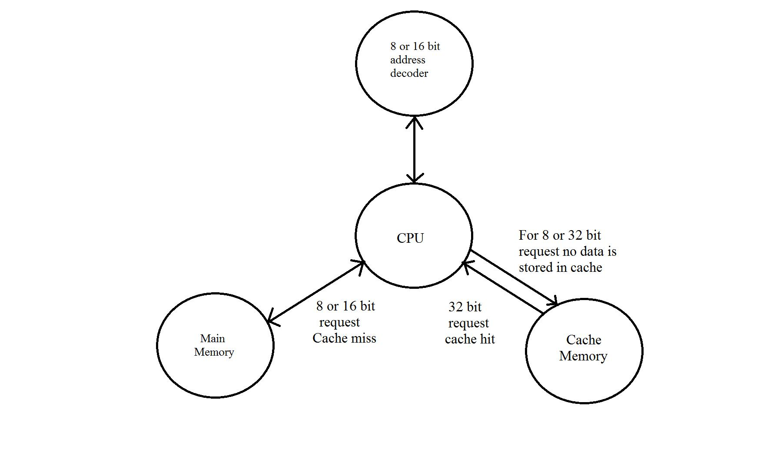
Page 18

- I/O TRANSFERS ARE NON-CACHEABLE

In this project, any data transfers from input or output devices are non-cacheable i.e.

data is directly written or read from main memory without using cache.
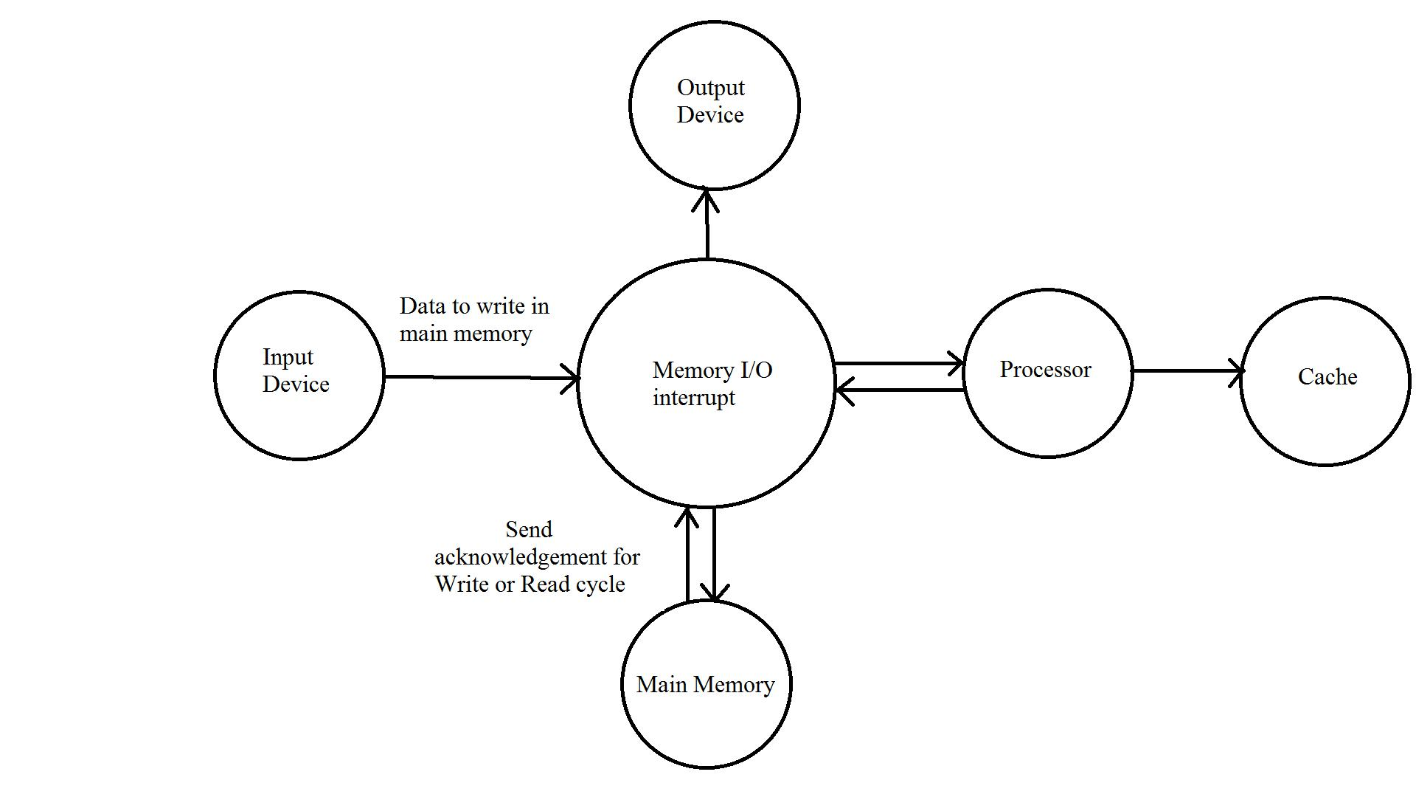
Page 19

    - READ CACHE MISS LONG WORD ACCESS

- LW 0 – LW 12

  - The transfer will start from the address accessed till the end of the line boundary and then rap around to the address.
  - The first data is transferred to the CPU at the same time to the Cache.

- LW 13 – LW 14 are non-cacheable, however the requested data is transferred to the CPU.

- LW 15

  - Is non-cacheable, data transferred to the CPU.

  - After CPU receives this long word, entire next consecutive line is transferred to the cache.
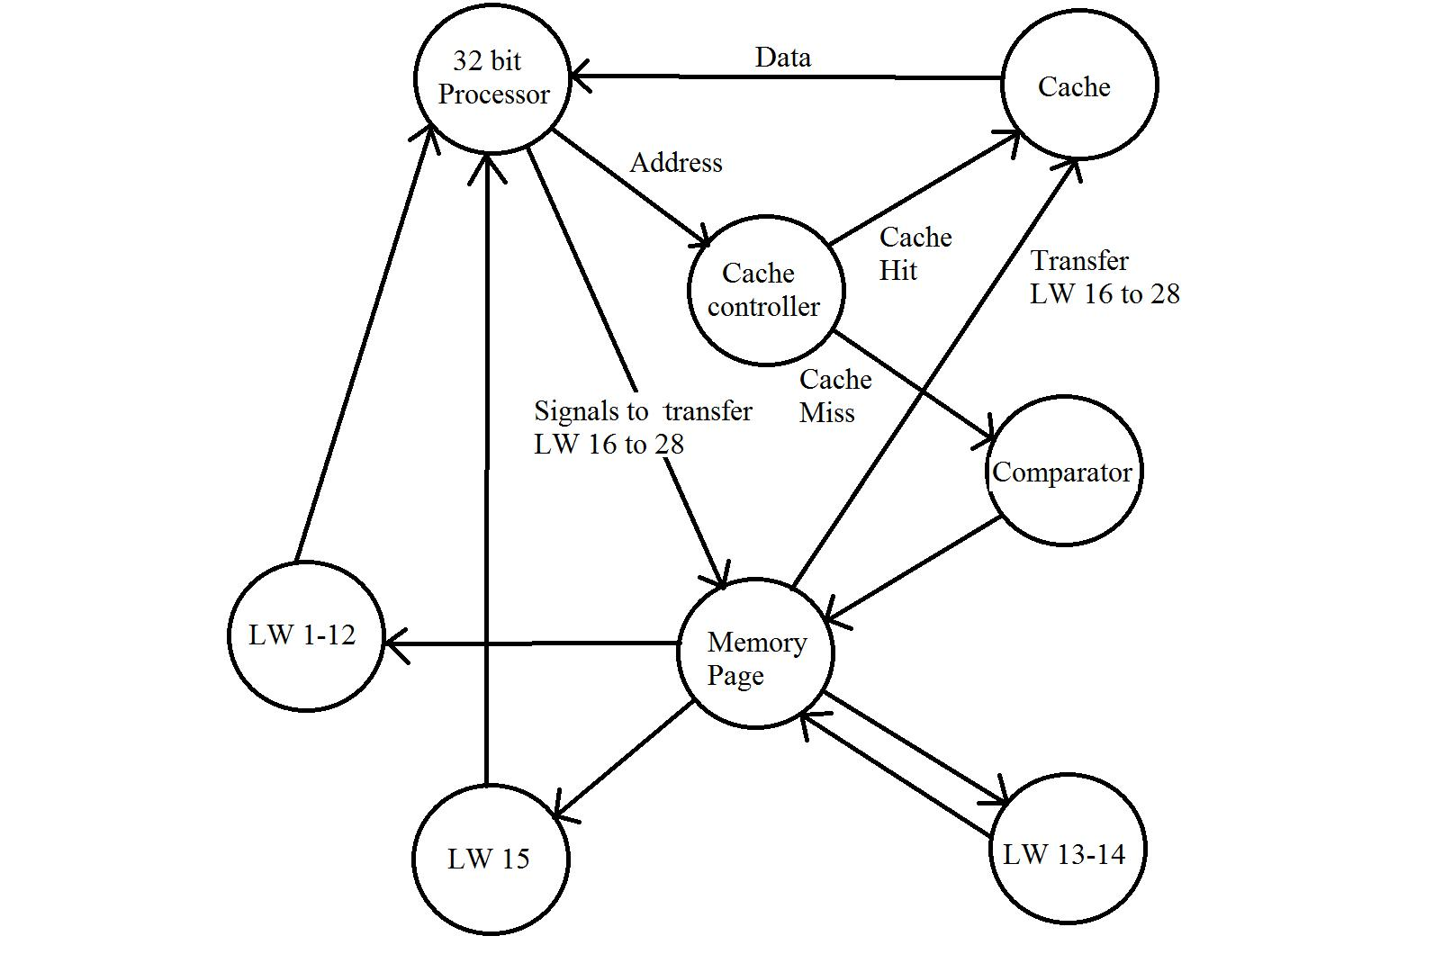
Page 20

- CACHE WRITE

The performance of a cache can be quantified in terms of the hit and miss rates, the cost of a hit, and the miss penalty, where a cache hit is a memory access that finds data in the cache and a cache miss is one that does not. As reading the required word in the cache does not affect the cache contents, there can be no discrepancy between the cache word and the copy held in the main memory after a memory read instruction. However, in general, writing can occur to cache words and it is possible that the cache word and copy held in the main memory may be different. It is necessary to keep the cache and the main memory copy identical if input/output transfers operate on the main memory contents, or if multiple processors operate on the main memory, as in a shared memory multiple processor system.

There are two principal alternative mechanisms to update the main memory, namely the write-through mechanism and the write-back mechanism.

WRITE-THROUGH MECHANISM

In the write-though mechanism, every write operation to the cache is repeated to the main memory, normally at the same time. The additional write operation to the main memory will, of course, take much longer than to the cache and will dominate the access time for write operations.

WRITE-BACK MECHANISM

In the write-back mechanism, the write operation to the main memory is only done at block replacement time. At this time, the block displaced by the incoming block might be written back to the main memory irrespective of whether the block has been altered.

CACHE HIT AND MISS

If the cache has the data when we access it, the cache is said to have a hit. Otherwise, it has a miss.
Page 21

Hit rate = number of hits / number of cache accesses

Miss rate = number of misses / number of cache accesses = 1 – hit rate

CAUSE OF CACHE MISSES

We can categorize the causes of cache misses in three. It is also called 3 C’s

Compulsory miss:

When a data is accessed first time, it is not in the cache. This is called compulsory miss.

Conflict miss:

Suppose a data loaded and replaced by some other data. hence it is accessed again, it

is not in the cache because it is replaced. This is called conflict miss.

Capacity miss:

In a fully associative cache, we reduce the possibility of conflict misses by using all the available cache lines. But if all the lines are in use, then one of them should be replaced. And miss can occur when we try to access the replaced data. This is called capacity miss. The notion of capacity miss can be a little bit confusing. We need to know that capacity miss happens only in fully associative cache.

A. CACHE WRITE MISS IS NON – CACHEABLE

If the data is not present is cache, then there is a cache miss. In such cases generally, the data is written back into cache for increasing performance. In this project, cache write miss is non-cacheable i.e. whatever is the data miss it is not written into cache .
Page 22
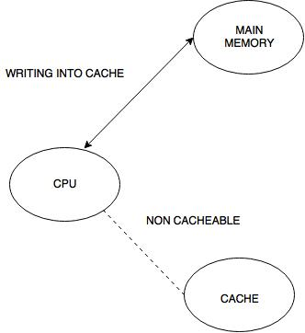

B. CACHEWRITEHIT–WRITEBACKPOLICY

Write-back normally handles write misses as allocate on write, as opposed to write-through, which often handles write misses as Non-allocate on write.

The write-back mechanism usually only writes back lines that have been altered. However, under this policy the complete block is written back, even if only one word in the block has been altered, and thus the policy results in more traffic than is necessary, especially for memory data paths narrower than a line, but still there is usually less memory traffic than write-through, which causes every alteration to be recorded in the main memory. The write-back scheme can also be enhanced by incorporating buffers to hold information to be written back to the main memory, just as is
Page 23

possible and normally done with write-through.

Write-back workflow:

- Each block in a write-back cache needs a dirty bit to indicate whether or not it must be saved to main memory before being replaced—otherwise we might perform unnecessary write backs.

- Notice the penalty for the main memory access will not be applied until the execution of some subsequent instruction following the write.

- The advantage of write-back caches is that not all write operations need to access main memory, as with write-through caches.

- If a single address is frequently written to, then it doesn’t pay to keep writing that data through to main memory.

- If several bytes within the same cache block are modified, they will only force one memory write operation at write-back time.

PERFORMANCE

- Higher performance than write-through caches

- Cache lines that are written at least once tend to be written enough times to make writing the entire cache line back once when it is evicted, more efficient than sending each write to the next level of the hierarchy as it occurs
Page 24
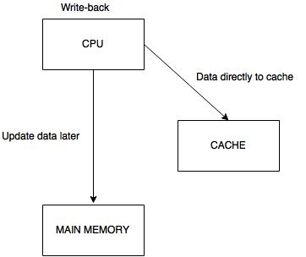

Write-back is faster but it becomes complicated when multi cores sharing memory
Page 25

- BUS SNOOPING CIRCUITS – MESI PROTOCOL

Processors providing cache coherence commonly implement a MESI protocol - where the letters of the acronym represent the four states that a cache line may be in: Invalid - cache line is not valid

Exclusive - cache has the only copy of the data. The memory is valid.

Shared - More than one cache is holding a copy of this line. The memory copy is valid.

Modified - The line has been modified. The memory copy is invalid.

OPERATION

In a typical system, several caches share a common bus to main memory. Each also has an attached CPU which issues read and write requests. The caches' collective goal is to minimize the use of the shared main memory.

A cache line may satisfy a read from any state except Invalid. An Invalid line must be fetched (to the Shared or Exclusive states) to satisfy a read.

A write may only be performed if the cache line is in the Modified or Exclusive state. If it is in the Shared state, all other cached copies must be invalidated first. This is typically done by a broadcast operation known as Request for Ownership (RFO).

A cache may discard a non-Modified line (i.e. Shared or Exclusive) at any time, changing to the Invalid state. A Modified line must be written back first.

A cache that holds a line in the Modified state must snoop (intercept) all attempted reads (from all of the other caches in the system) of the corresponding main memory location and insert the data that it holds. This is typically done by forcing the read to back off (i.e. retry later), then writing the data to main memory and changing the cache line to the Shared state.
Page 26
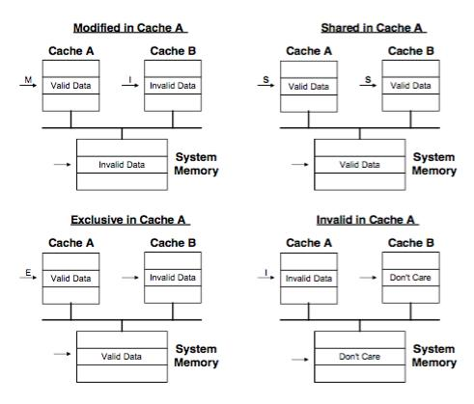

A cache that holds a line in the Shared state must listen for invalidate or request-for-ownership broadcasts from other caches, and discard the line (by moving it into Invalid state) on a match.

A cache that holds a line in the Exclusive state must also snoop all read transactions from all other caches, and move the line to Shared state on a match.

The Modified and Exclusive states are always precise: i.e. they match the true cache line ownership situation in the system. The Shared state may be imprecise: if another cache discards a Shared line, this cache may become the sole owner of that cache line, but it will not be promoted to Exclusive
Page 27

state. Other caches do not broadcast notices when they discard cache lines, and this cache could not use such notifications without maintaining a count of the number of shared copies.

In that sense the Exclusive state is an opportunistic optimization: If the CPU wants to modify a cache line that is in state S, a bus transaction is necessary to invalidate all other cached copies. State E enables modifying a cache line with no bus transaction.

MESI – LOCALLY INITIATED ACCESSES
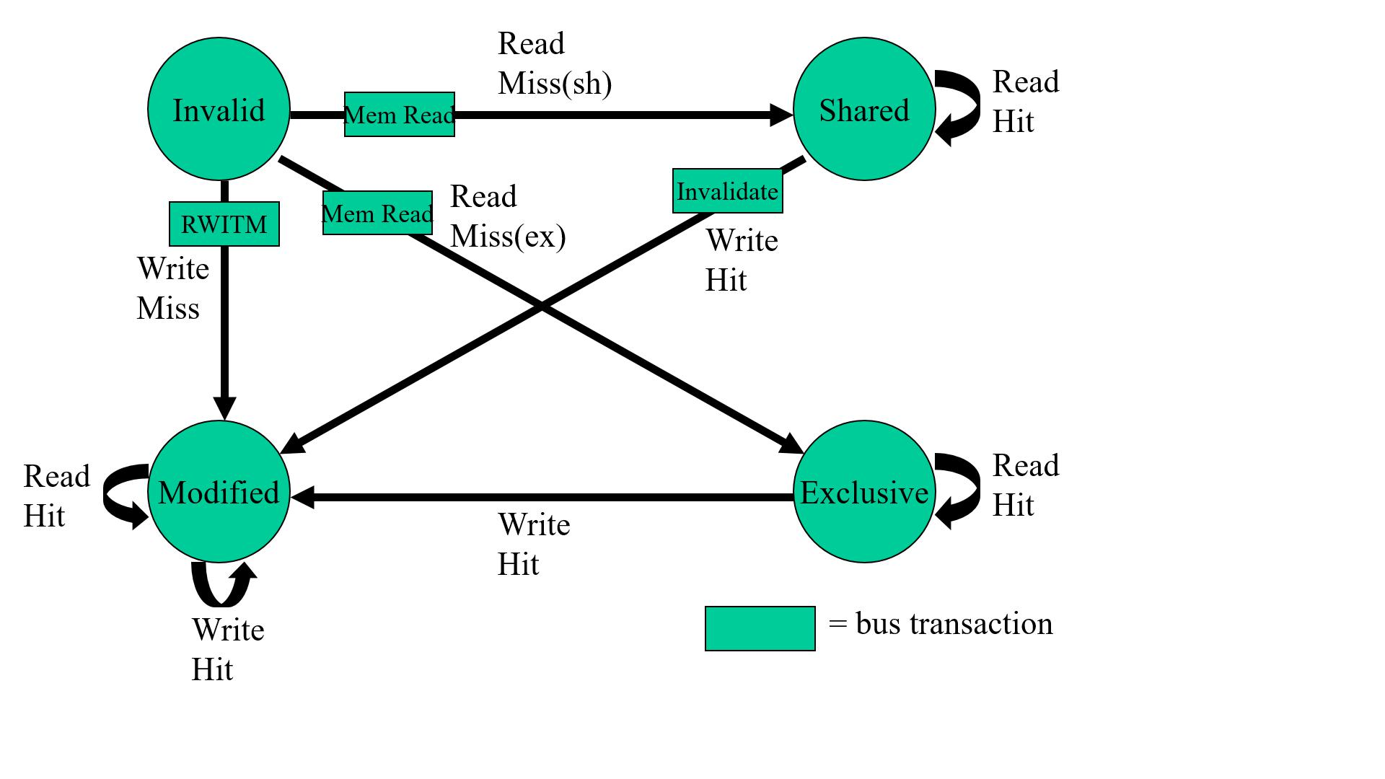
Page 28

- MEMORY PAGES 100 TO 200 ARE NON-

CACHEABLE

In this project, it is mentioned that 100 to 200 pages of main memory are non-cacheable. We have 4MB main memory which comprises 2048 pages each comprising 2KB data. Hence data present in 100 to 200 pages is not referenced or written to cache. So there won’t be a copy of that data in cache.
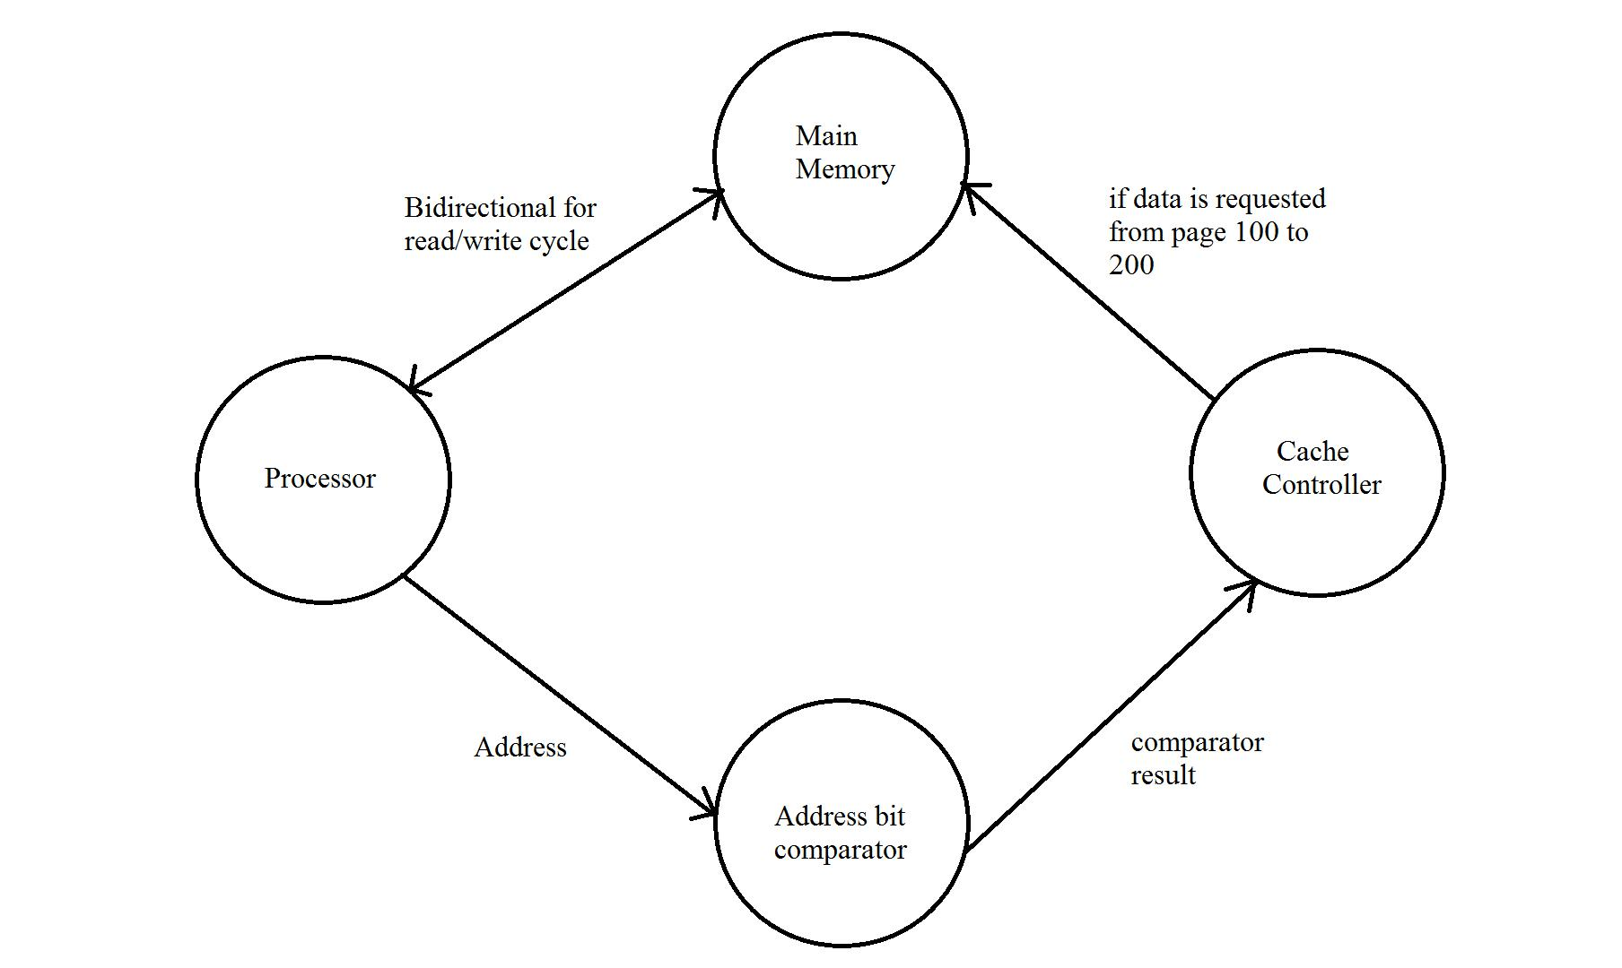
Page 29

- FLUSH CIRCUITRY TO INVALIDATE THE ENTIRE CACHE

When dirty lines are flushed from the cache, the component will ensure that their contents are synchronized with main memory. Some architectures provide a facility for explicitly flushing a line to memory. For this purpose, the component provides flush which can be driven with an address. If the address falls on a line that is present and dirty, it will be flushed to memory and marked as not dirty. A line can be flushed and invalidated in one atomic operation by driving the flush-and-invalidate pin. The entire cache can be flushed by driving flush-all.

The data cache has flexible cleaning and flushing utilities that enable the following operations:

- We can invalidate the whole data cache (flush data cache) in one operation without writing back dirty data.

- We can invalidate individual lines without writing back any dirty data (flush data cache single entry).

- We can perform cleaning on a line-by-line basis. The data is only written back through the write buffer when a dirty line is encountered, and the cleaned line remains in the cache (clean data cache single entry). We can clean cache lines using either their index within the data cache, or their address within memory.

- We can clean and flush individual lines in one operation, using either their index within the data cache, or their address within memory.
Page 30
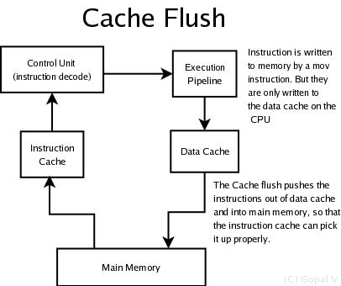

Page 31

CONCLUSION

A 32-bit cache controller has been designed as per the project requirements with 4-way set-associative mapping and different cache write policies. It is observed that in order to improve the cache performance, miss rate can be reduced. Reducing the time to hit in the cache also yields in high performance. It is observed that speed of read/ write operation and their performance during data transfers can be improved using cache.
Page 32

REFERENCES

- Gopal.V — 2010 “cache flush circuitry “.

- “Flushing” at sourceware.org.

- ARM ‘The Architecture for the Digital World’.

- “Shared-memory Architectures’’ Adapted from a lecture by Ian Watson, University of Machester.

- MESI Protocol (Wikipedia)

- Cache Write Policies and Performance by Norman P. Jouppi

- Cache Design

- Introduction to Cache Memory

- Cache Memory by S.Dandamudi

